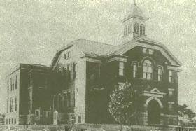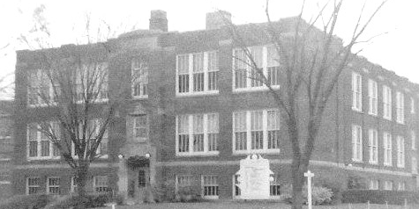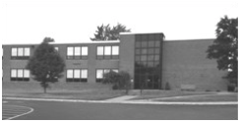

Stow Munroe Falls High School Alumni Association (SMFHSAA)
P.O. Box 2626, Stow, OH 44224
November 2022 Newsletter

THE PRESIDENT’S PEN: Since our newsletter in June…

- Our monthly Coffee, Cocoa and Company gatherings continue. We meet on the 4th Wednesday of the month at 11:00 am. During the warm months we’ve been meeting at Silver Springs Park out back in the Oak Tree pavilion. In October we moved indoors. We are meeting at Eddy’s Restaurant located at 4581 Kent Rd. (just east of Fishcreek Rd.) at 11:00 am. Please let me know if you will be joining us. Check our facebook page for updates.

- Aug. 13 – Our 2022 Alumni Picnic was held at Silver Springs Leona Farris Lodge. 113 attendees enjoyed a meal of lasagna, chicken, pulled pork, roasted redskins, mac ‘n cheese, tossed salad and cupcakes as they chatted the night away. We were pleased to have the classes of ’62 and ’67 celebrating their reunions with us. Thank you to those who donated items for the silent auction, those who bid/won those items and those who reserved seating at a scholarship tables. Proceeds from the picnic directly impact our scholarship fund. In our absence Rick and I send out a huge thank you to all the alumni that stepped in and helped that day – Linda Berthold, Jim Betz, Bob and Judy Cooper, Jill France, Jason Hanna, Bonnie Housley, Mary and Buzz Hudson and daughter Courtney, Bill Kovacs, Dave and Lin Krebs, Audrey Lutz, Rick Martin, Blaine Mayer, Cathy Pack, Bob Platt and Ralph Richardson.

- Oct. 12 - 23 attended the Cash Mob at the Tip Top (Flag Pole). Alumni from the classes of ’63 through ’91 attended. It’s always an enjoyable evening.

- The Alumni Association continues to support our local Bulldog Bags, Inc. Eight to ten alumni pack bags of food twice a month during the school year. This year we are packing and distributing over 700 bags. If you are interested in helping, let me know.

Cheryl

ALUMNI CHRISTMAS DINNER: Join fellow alumni for dinner and a relaxing evening on Thursday, December 15, 2022 at 5:30 pm at Red Lobster in Stow (1090 Graham Rd., back room). We’ll order off the menu. Reservations are required and due no later than Dec 11. Hope to see you there!  FEBRUARY ALUMNI CASH MOB: Our winter Cash Mob will be held at Isaly’s on Wednesday, February 8th at 11:30 am. Isaly’s is located at 3310 Kent Rd. We’ll be ordering off the menu. If you plan to attend please contact Cheryl no later than Feb. 3. Check our fb group for updates. Join us and support a small local business.  PLAN AHEAD: Aug 12, 2023 Annual Alumni Picnic and Scholarship Fundraiser held at Roses Run Country Club patio. More info in the June 2023 newsletter.  SMFHS ALUMNI ASSOCIATION OFFICERS:  President – Cheryl Ruble Hanna ’68 (rchanna70@att.net, 330.928.5880) 1st VP – Debbie Davis Gilbert ‘68 2nd VP – Bob Platt ‘62  Treasurer – Buzz Hudson ‘63 Secretary – Mary Helton Hudson ‘67  Jill Shuman France ’67, Newsletter editor  Visit us on Facebook at: Stow High School Alumni Association or on our website at stowhighalumni.com | SCHOLARSHIP DONATION DRIVE: Our Stow Munroe Falls High School scholarship donation drive is ongoing. Donations in any amount are greatly appreciated. All donations received from alumni or classes support our scholarship fund for graduating seniors. Donations may be sent to: SHSAA, P.O. Box 2626, Stow, OH 44224. Thank you for your continued support!  SCHOLARSHIP DONORS: Many thanks to the generous alumni who have donated to our scholarship fund since our newsletter in June. We appreciate the donations from John Thomas '77,  Sandy Haugh Quinn '67 and John Oblak '58 (in memory of his parents).  YEARBOOK SEARCH AND SALES: The SMFHS Alumni Association frequently receives requests for yearbooks. Currently there are 75 alumni looking for 1941-2019 Stoanno’s. If you have a Stoanno that you no longer need please consider a donation to the Alumni Association which in turn supports our scholarship fund. Many thanks to Bob Oziomek ‘84 and Janet Hanson Vittorio ‘64 for the yearbook and memorabilia donations! As yearbooks are donated to the association they are posted on our facebook page and in the newsletter. Contact Cheryl if you’d like to donate or purchase a yearbook. Donated yearbooks are available to purchase for $15 (local pick up) or $25 (includes postage). Currently available on a first-come first-served basis are ’53, ‘54, ’56, ’78, ’91, ’93 -’99, ‘00-’07 Stoanno’s.  Stow-Munroe Falls High School Alumni Association  (SHSAA)  P.O. Box 2626  Stow, OH. 44224

